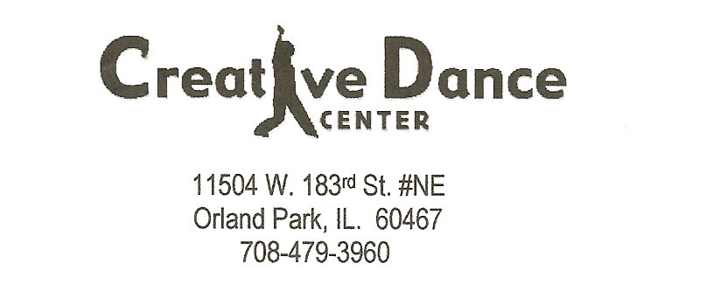

Assumption of the Risk and Waiver of Liability Relating to Coronavirus/COVID-19

The novel coronavirus, COVID-19, has been declared a worldwide pandemic by the World Health Organization. COVID-19 is extremely contagious and is believed to spread mainly from person-to-person contact. As a result, federal, state, and local governments and federal and state health agencies recommend social distancing as much as possible.

Creative Dance Center has put in place preventative measures to reduce the spread of COVID-19; however, Creative Dance Center cannot guarantee that you or your child(ren) will not become infected with COVID-19.

>>>>>>>>>>>>>>>>>>>>>>>>>>>>>>>>>>>>>>>>>>>>>>>>>>>>>>

By signing this agreement, I acknowledge the contagious nature of COVID-19 and voluntarily assume the risk that my child(ren) and I may be exposed to or infected by COVID-19 by attending classes at the studio. That such exposure or infection may result in personal injury, illness. Permanent disability and death. I understand that the risk of becoming exposed to or infected by COVID-19 at the studio may result from the actions, omissions, or negligence of myself and others, including, but not limited to, Creative Dance centers employees, volunteers, and program participants and their families.

I voluntarily agree to assume all of the foregoing risks and accept sole
Responsibility for any injury to my child(ren) or myself (including, but not limited to, personal injury, disability, and death), illness, damage, loss, claim, liability, or expense, of any kind, that I or my child(ren) may experience or incur in connection with my child(ren’s) attendance at Creative Dance Center or participation in studios programming (“Claims”). On my behalf, and on behalf of my children, I hereby release, covenant not to sue, discharge, and hold harmless Creative Dance Center, its employees, agents, and representatives, of and from claims, including all liabilities, claims, actions, damages, costs or expenses of any kind arising out of or relating thereto. I understand and agree that this release includes any Claims based on the actions, omissions, or negligence of Creative Dance Center, its employees, agents, and representatives, whether a COVID-19 infection occurs before, during or after participation in any of Creative Dance Center’s programs.

Signature of Parent/Guardian Date

______________________________________________________________________________Print Name of Parent/Guardian

Name of Studio Participants(s)

______________________________________________________________________________

